Practical - 4
Practical Title: JavaScript DOM Manipulation, Event Handling, and UI Interactivity
Problem Definition: Add dynamic UI components such as collapsible FAQ, modal popup, image/content slider, notification banner, hamburger menu, and light/dark theme switcher using JavaScript.Theory

How are DOM elements selected and modified?
Answer: The Document Object Model (DOM) represents the structure of a webpage as a tree of objects. It allows JavaScript to access and modify the content, structure, and styling of HTML elements dynamically. Enables changing HTML content and attributes using JavaScript.

Are event listeners attached correctly?
Answer: To check if event listeners are attached correctly, you can use the
addEventListener () method to attach an event handler to an element.

3. Is local Storage used for remembering theme choice?
Answer: Yes, Local Storage is used for remembering theme choices. It allows websites to store and retrieve theme preferences, such as light or dark mode, even after the user reloads the page or closes the browser. This is achieved by saving the theme selection in Local Storage and retrieving it upon page load. This method ensures that the user's preferred theme is preserved, providing a seamless and personalized browsing experience.

4. Does interactivity improve usability without breaking accessibility?
Answer: Yes, interactivity can enhance usability without compromising accessibility if designed intentionally with inclusive principles and best practices. The nuanced balance involves understanding the overlaps and potential conflicts between interactive features and accessibility requirements.

Implementation/ Output/Result
Properties Used
getElementById(), querySelector(), addEventListener(), classList.toggle(), localStorage, Form Validation, Regular Expression, alert(), preventDefault(), textContent / innerHTML, disabled, style.display
- Evidence of Work (Screenshots)

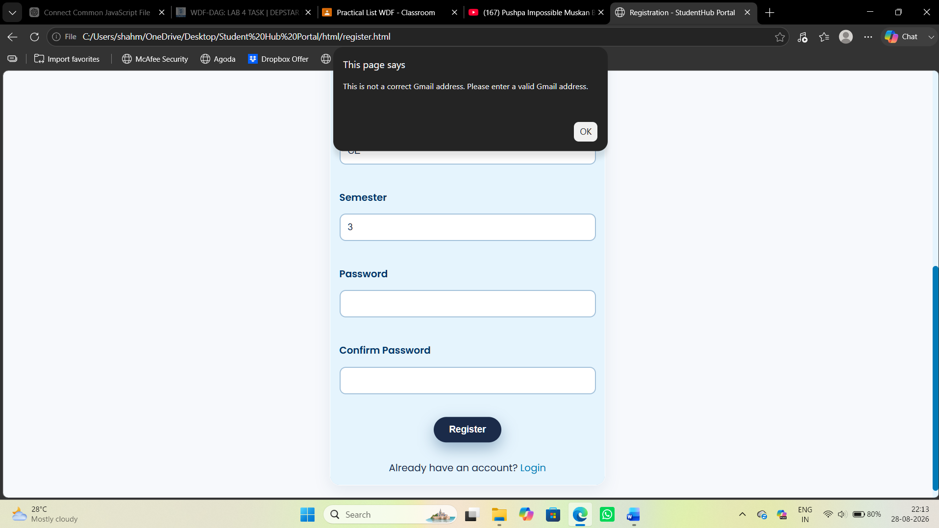

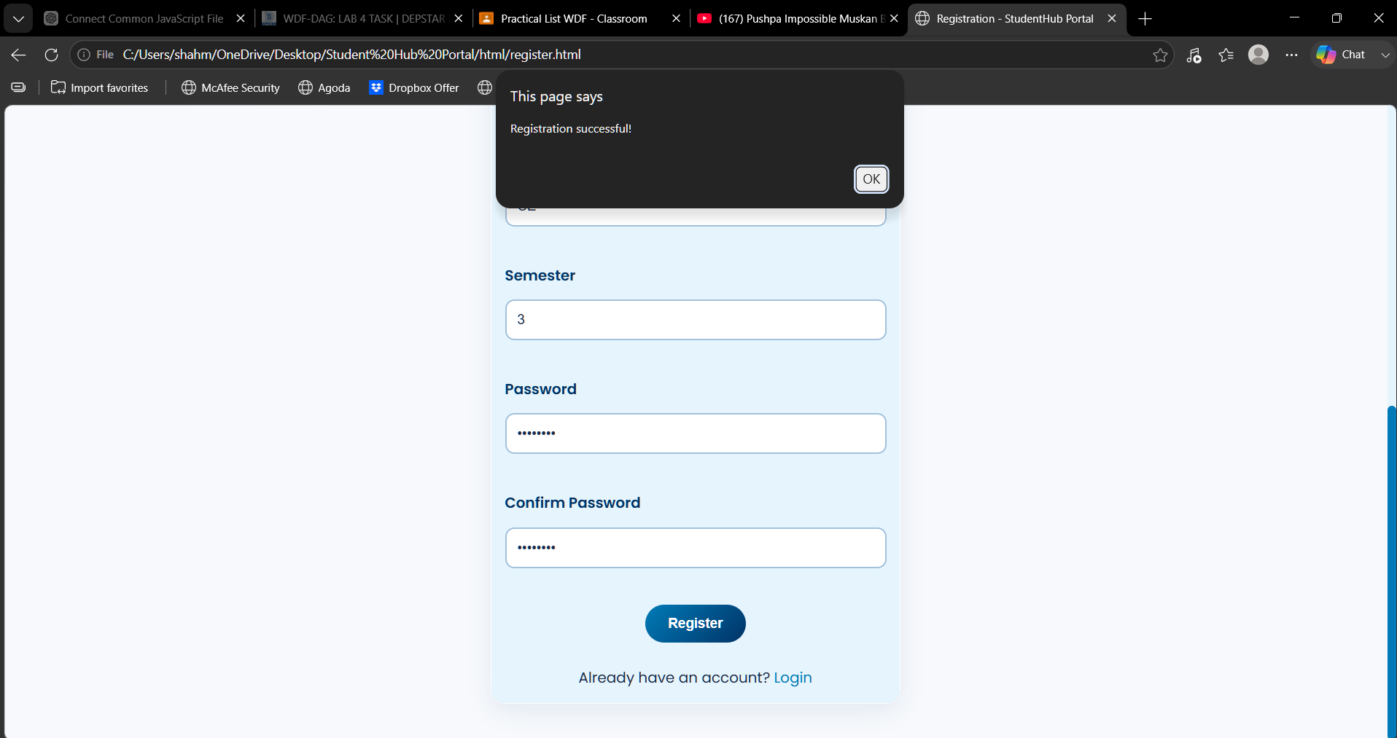

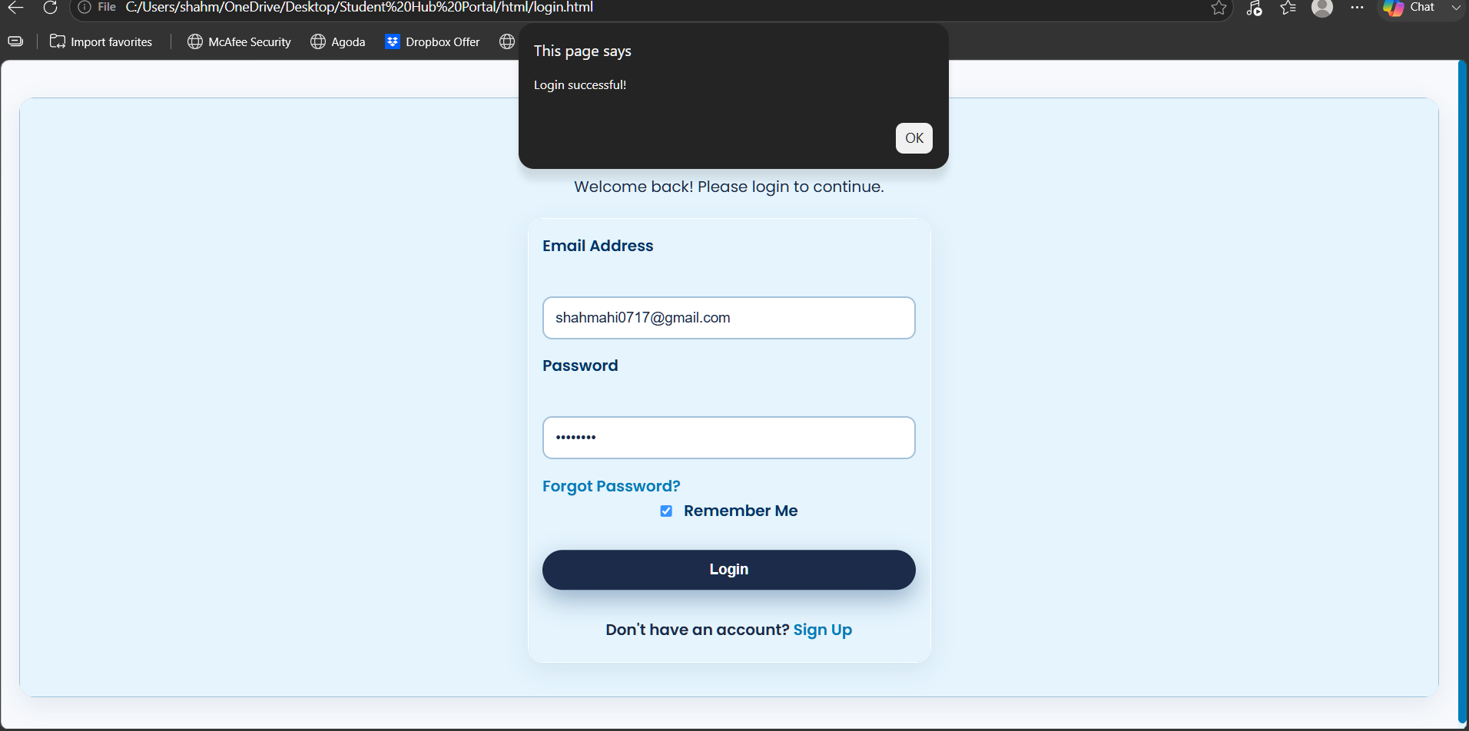

C. GitHub Repository Link: https://github.com/shahmahi0717/Student-Hub-Portal

D. Challenges Faced:
- Connecting one common external JavaScript file to all HTML pages.
- Handling form validation for different input fields.
- Making the sidebar toggle work properly.
- Ensuring JavaScript works correctly with different HTML elements.

E. Learning Outcomes:
- Learned how to use external JavaScript with multiple HTML pages.
- Improved understanding of form validation and user input handling.
- Learned how to use events and DOM manipulation.
- Understood how JavaScript can make a website interactive and user-friendly

Faculty Remarks: (Keep this blank for faculty)

